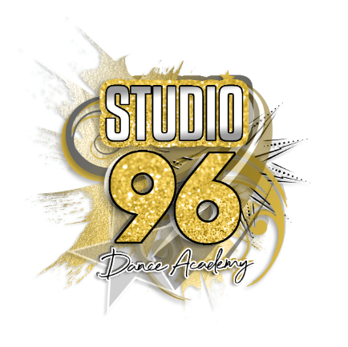

Community Interest Company (CIC)
Social Media Policy

Introduction
This Social Media Policy has been produced and agreed by the Directors.
The company recognises that there is no doubt that social media, including most notably Instagram, Facebook and Twitter, can bring substantial benefit to an individual or organisation if managed appropriately.
Social media provides an opportunity to promote our company, Hirers, individuals and groups, communicate key messages, as well as allowing individuals to connect and share ideas at a low cost and to a wide audience. However, if not managed appropriately misuse of social media could well be a public relations nightmare for the Company, and depending on the circumstances, could mean that it would face legal or ‘regulatory’ action.
Remember that social media is an area of public comment, and any person or organisation is liable for any statement it makes in this sphere as if the same statement were being made in the media. Any person or organisation ‘running’ a ‘public’ profile, page or account may well have several journalists as followers or friends. Thus, any comments, posts, photos, videos, etc. provided on social media sites have to be considered the same as communicating with the press/media.
Overall, all members or users of the Company must fully comply with this social media policy.
Compliance with this policy is a condition of Staff, Hirer’s and volunteers and any noncompliance will be subject to the company’s disciplinary procedures. The Directors have the right to take appropriate action in the event of any Staff, Hirer’s or volunteers breaching the terms of this policy (this includes family and friends).

Policy Item 1:
Be Authentic, Constructive and Respectful On authorised Company Facebook profiles/pages and Twitter accounts, and also on any personal profiles/pages and accounts.
All associates with this company must never post malicious, misleading or unfair content about the company, its members, other Clubs, sponsors or any other organisation or person.
No content should be posted that is obscene, defamatory, threatening (harassing, bullying, etc) disparaging or discriminatory concerning the Company, its members, other Clubs, sponsors, or any other organisation or person.
Comments must not be posted that you would not say directly to another person or organisation – you must first consider how other people might react before you post.
If you respond to published comments that you may consider unfair, always be accurate and professional.
Policy Item 2:
Be Respectful and Courteous on authorised Studio 96 Dance Academy’s Facebook profiles/pages and Twitter accounts, and on any personal profiles/pages and accounts.

All Staff, Hirer’s and volunteers must:
Think before you post anything or respond to someone on-line and ensure that all of your communications are respectful and courteous. Once you have put something online, there is almost no taking it back and it is almost impossible to delete. Your comments may be seen by the media, sponsors, etc. and could impact negatively on you or the Studio.
Avoid getting into heated discussions online or talking about sensitive issues. Speak to a member of the Company’s Directors if you feel as though someone is trying to provoke a response from you or harasses/threatens you online.
Think very carefully before you post and/or tag an image.
Be fully aware that the images you share online will reflect on yourself and Studio 96 Dance Academy CIC, so it is important that you consider this before uploading or tagging photos and videos. Also be aware that these photos may be taken out of context and used by the media or other people - so if you are not happy for the image to be shared publicly, it should not be placed online.
Respect other people’s accounts and devices.
If there is an occasion where a Staff, Hirer’s or volunteers leaves a mobile phone unattended or has not properly logged out of an account, do not use that person’s device or account to harass others or impersonate that person and cause them and/or the Studio ‘humiliation’.

Policy Item 3:
Respect Copyright and Intellectual Property Regarding authorised Studio 96 Dance Academy CIC Facebook profiles/pages and Twitter accounts, and also on any personal profiles/pages and accounts.

All Staff, Hirer’s and volunteers must:
Respect other people’s intellectual property including trademarked names and slogans and copyrighted material (it is best practice to assume that all content online is protected by copyright).
Make sure you have permission to post copyright items, properly attribute the work to the copyright owner where required, and never use someone else’s work as if it were your own. If you are unsure as to who might own an item of content, it’s better to err on the side of caution and not post the content at all.
In addition to respecting the laws pertaining to copyright and Intellectual Property, respect all laws and regulations in relation to privacy (data protection).

Policy Item 4:
Respect Confidentiality regarding authorised Studio 96 Dance Academy CIC Facebook profiles/pages and Twitter accounts, and also on any personal profiles/pages and accounts.

All Staff, Hirer’s and volunteers must:
Only reference information that is publicly available.
Not disclose any information that is confidential or proprietary to the Studio, its Staff, Hirer’s and volunteers, its suppliers, sponsors or any third party that has confidentially disclosed information to the Studio.
Not cite, post or reference the Studio it’s Staff, Hirer’s or volunteers, other Clubs, sponsors, or any organisation or person without approval from the Directors.

Policy Item 5:
Be Careful in Use of Logos, Trademarks or Materials Regarding authorised Club Facebook profiles/pages and Twitter accounts, and also on any personal profiles/pages and accounts, all members must not use the logos, trademarks or materials of the Club, other Clubs, sponsors or any organisation, unless it has been cleared for public use or been otherwise approved by the Directors.

Policy Item 6:
Monitoring all Staff, Hirer’s and volunteers : must note that the Director’s will be regularly monitoring use of social media by Staff, Hirer’s and volunteers to ensure that all are in compliance with this social media policy.
Whilst the Studio may need to take formal action in appropriate cases, all Staff, Hirer’s and volunteers must acknowledge what is expected in terms of social media use.

Date of review: January 2021
Date of next review: January 2024

