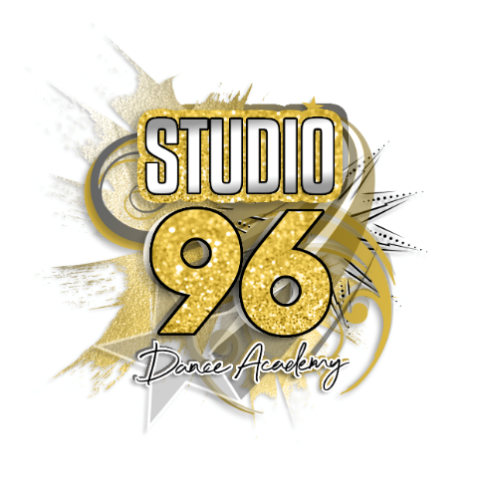

Community Interest Company (CIC)

STUDIO 96 DANCE ACADEMY CIC
GDPR POLICY

Studio 96 Dance Academy CIC is committed to protecting you and your dependents’ personal information. We are committed to providing a safe environment for all our Staff, Hirer’s, volunteers, and public who are involved at Studio 96 Dance Academy CIC, both physically and virtually (online). This Privacy Statement relates to the use of any personal information provided to us online or via application forms, telephone, email exchange, letters, or correspondence.
Whenever you provide such information, we are legally obliged to use your information in line with current legislation concerning the protection of personal information, including the Data Protection Act 1998 and the General Data Protection Regulations.

The legislation sets out various data protection principles. These include that personal information is:
- Used fairly and lawfully
- Used for limited, specifically stated purposes
- Used in a way that is adequate, relevant, and not excessive
- Accurate
- Kept for no longer than is necessary
- Kept safe and secure
- Not transferred outside the European economic area without adequate protection
The legislation conveys various individual rights. These include the following:
- The right to be informed
- The right of access
- The right to rectification
- The right to erase
- The right to restrict processing
- The right to data portability
- The right to object
You have the rights to access the information we store about you. If you wish to access, alter or query any information please email studio96danceacademy@gmail.com

You have the right to withdraw your consent at any time. The withdrawal of consent shall not affect the lawfulness of processing based on consent before its withdrawal.
You can email studio96danceacademy@gmail.com stating that you are no longer are a member and wish to be deleted from the applications . If you wish to opt out of any other form of contact (mail, phone calls) please email studio96danceacademy@gmail.com
The legislation requires that there be a clear legal basis for processing personal information. In general Studio 96 Dance Academy CIC relies on the individual’s consent to process their data.
When you hire or sign up to any Studio 96 Dance Academy CIC classes, activities or workshops, we may collect and store personal information about you. This can consist of information such as your name, email address, postal address, telephone or mobile number and date of birth, depending on how you are engaging with us. By submitting your details, you enable us to provide you with the products or services that you have selected.
WHO ARE WE AND WHAT DO WE OFFER?

Studio 96 Dance Academy CIC offer Cheer and Dance provision in recreational and Competive classes in:

- Pom Dance
- Hip Hop
- Street Dance
- Lyrical
- Cheerleading
- Tumblings
- Technical Classes
- Workshops
- Baby and Toddler groups
- Keep fit classes
- Studio’s to hire

Social Media and Photo Consent
Studio 96 Dance Academy CIC use Facebook, Instagram and Twitter for media purposes.
Studio 96 Dance Academy CIC do use footage which is posted to promote the Studio and programs we deliver.
When signing up to Studio 96 Dance Academy CIC Applications, unless notifed Studio 96 Dance Academy CIC will use photos, socail media and in local or National press.
It is the hirer, parents or guardians responsibility to notify Studio 96 Dance Academy CIC if we are not allowed to use socail media or photos of a member, if you do not consent you must email studio96danceacademy@gmail.com
When taking pictures or filming during any sessions we provide at Studio 96 Dance Academy CIC we ask organisations/hirers /parental/guardian’s permission. Studio 96 Dance Academy CIC may use the images resulting from the photography/video filming, and any reproductions or adaptations of the images for fundraising, publicity, or other purposes to help achieve the Studio’s aim. This might include (but is not limited to), the right to use them in their printed and online publicity, social media, press releases and funding applications.
Studio 96 Dance Academy CIC does NOT share your personal information with third parties, unless clearly stated. We do NOT sell your data, and neither do we buy data from third parties.

HOW DO WE USE YOUR INFORMATION?

Studio 96 Dance Academy CIC store your information for Studio use only. Our records will hold the following information:
- The name and contact details of staff, hirer’s and those who attend sessions provided by the Studio
- Studio 96 Dance Academy CIC Applications used to hold data such as Team App/Coacha are password protected
- We want to keep you notified about INFORMATION REGARDING CLASSES OR EVENTS at the Studio.

WHAT INFORMATION DO WE COLLECT AND WHERE IS IT STORED?

The information we collect is what you provide us with when you sign up to Studio classes complete Waiver/COVID forms, Team App/Coacha, mobile phone numbers stored on Directors phoned if required.

- Name
- Email address
- Phone number
- Home address
- Date of Birth
- Medical Information
- Emergency Contact

Studio 96 Dance Academy CIC will store your information on the following Applications and Websites:
- Team App
- Whats App
- Paper print

WHO CAN ACCESS MY INFORMATION?

Studio 96 Dance Academy CIC Directors

HOW LONG WE KEEP YOUR INFORMATION?
For as long as you keep in touch with us, we will keep your information stored. If we do not hear from you for 1 month, your information will be deleted.

Date of review: JANUARY 2021
Date of next review: January 2024

