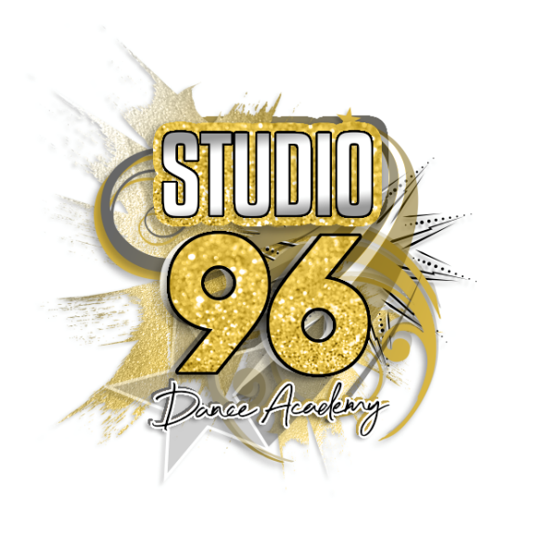

Community Interest Company (CIC)

Equality and Diversity Policy

The aim of this policy is to ensure that everyone who attends Studio 96 Dance Academy is treated fairly and with respect ,
Other organisations are not denied access to Studio 96 Dance Academy CIC because of a discriminatory reason.
This policy is fully supported by Studio 96 Dance Academy CIC Directors, who are responsible for the Implementation and review of this policy.
Studio 96 Dance Academy CIC will therefore adhere the following:
- Be responsibility for setting standards and values to apply throughout the Studio at every level, as Cheerleading and Dance and Fitness classes should be enjoyed by all who want to participate in activities
- Be committed to eliminate discrimination by reason of gender, sexual orientation, race, nationality, ethnic origin, religion or belief, ability, or disability and to encourage equal opportunities
- Not discriminate or in any way treat anyone less favourably, on the grounds of gender, sexual orientation, race, nationality, ethnic origin, religion or belief, ability or disability

- Ensure that it treats all who attend the Studio fairly and with respect and will ensure that all members of the community have access to and have opportunities to take part in, and enjoy, it’s programme of activities and events on offer
- Not to tolerate harassment, bullying, abuse, or victimisation of any individual, including sexual or racially based harassment or other discriminatory behaviour, whether physical or verbal and work to ensure that such behaviour is met with appropriate action in whatever context it occurs
- be committed to the immediate investigation of a complaints of discrimination on the above grounds, once they have brought to attention. Complaints will be dealt with in accordance with the Complaints and Procedures Policy, where such a complaint is upheld, the Directors may impose such sanctions as it considers appropriate and proportionate to discriminatory behaviour
- be committed to taking positive action where inequalities exist and the development of a programme on-going training and awareness in order to promote the eradication of discrimination and to promote equality and diversity in all activities under taken at the Studio
- be committed to a policy of equal treatment of all who attend the Studio to abide by and adhere to these policies and the requirements of the relevant equalities legislation.
In the event that any person attending the Studio feels that s/he has suffered discrimination or harassment in any way or that the policies, rules or code of conduct have been broken they should follow the procedures below.
- The complainant should report the matter in writing/email
studio96danceacademy@gmail.com to the Director within 7 days. The report should include:
- details of what occurred
- details of when and where the occurrence took place
- any witness details and copies of any witness statements
- names of any others who have been treated in a similar way (providing those people consent to their names being named)
- details of any former complaints made about the incident, including dates and to whom such complaint was made
- an indication as to the desired outcome

- If the person accused of discriminatory behaviour is a Hirer, Instructor/coach/volunteer, the Director will regard the incident as a disciplinary issue and will follow procedures set.

- If the person accused of discriminatory behaviour is a non-volunteer, they
- will request that both parties to the complaint submit written evidence regarding this incident
- may decide (as it sole discretion) to uphold or dismiss the complaint without holding a hearing
- may (as it sole discretion) hold a hearing (whether or not such a hearing is requested is by either party) at which both parties will be entitled to attend and present their case
- will have the power to impose any or more of the following sanctions on any person found to be in breach of any policy (including the equality policy)
- warn as to future conduct
- suspend from membership
- remove from membership
- exclude a non-member from the facility, either temporarily or permanently
- turn down a non-members current and/ or future membership application
- will provide both parties with written reason for its decision to uphold or dismiss. The complaint within one (1) calendar month of such decision being made

Terminologies and descriptors

Types of discrimination

There are three (3) categories of discrimination direct, indirect and positive

- direct discrimination is where a person, in a group of people with the same circumstances, is treated less favourable than others in the group because of their race, gender, disability or sexuality
- indirect discrimination occurs where the effect of certain requirements, provision or practices imposed by an organisation has adverse impact disproportionately on one group or other. Indirect discrimination generally occurs when a rule or condition, which is applied equally to everyone, can be met by considerably smaller proportion of people from a particular group, the rule is to their advantage and it cannot be justified on other grounds
- positive discrimination is in favour of those who were formerly discriminated against, especially in provision of social and educational facilities and employment opportunities

Harassment can be described as inappropriate actions, behaviour, comments or physical contact, which may cause offence i.e mental or physical anxiety or hurt an individual.
- It may be related to gender, race disability, sexuality, age, religion, nationality or any personal characteristics of an individual
- Under the terms of the Criminal Justice Act 1994, harassment was made a criminal offence, punishable by and fined of up to £5000 and/or a prison sentence of up to six (6) months

Victimisation can be described as treating an individual less favourable than one would treat others because the individual has made a complaint for discrimination given evidence about such a complaint or raised a concern under the public interest (Disclosure) Act 1998
‘Positive action’ refers to a number of methods designed to counteract the effects of discrimination and to help eradicate stereotyping. It can be initiatives or activities that attempt to address imbalances by providing extra help, doing things in a different way or promoting opportunities in targeted places and groups. Under this broad meaning, positive action may include actions such as an introduction of discriminatory selection procedures, and training programmes or policies aimed at preventing sexual harassment. An example of positive action being taken is the appointment of a female coach to lead a session aimed at women, to specifically encourage uptake and participation by female players
Prejudice is literally prejudging someone. It is usually lead by negative, irrational feelings, resulting from preconceived attitudes and opinions.
Stereotyping is grouping or labelling people because they are of a particular ‘visible’ group and assuming they have particular traits they are considered to be characteristics of that group.
Dignity is about respectful, responsible, fair and humane behaviour, something that is reflected in the constitution.
Disadvantaged is where, as a result of discrimination, an individual or group is deprived of some or all resources and opportunities. This may affect people directly or indirectly.
Social exclusion is when people or areas suffer from one or a combination of linked problems, such as unemployment, poor skills, low income, high environment or lack of facilities.

Date of review: February 2021
Date of next review: January 2023

